12. Manage Installed Services

Tasks

1. Use the systemctl command to check the status of the sshd service on your Linux system and write down whether it is active, inactive, or failed.

ANS:

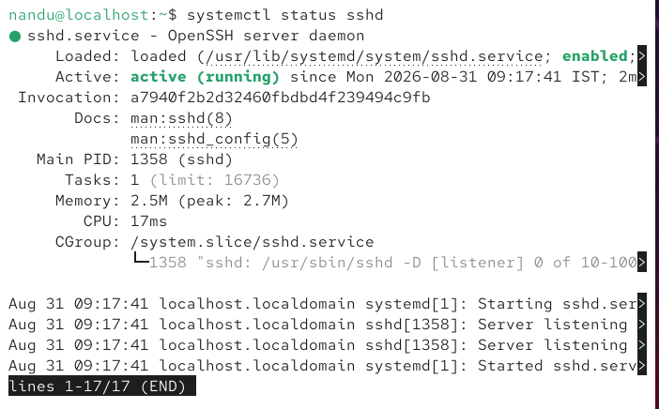

2. Start the nginx service using systemctl, then immediately stop it. After each action, verify the status and note the changes. Use 'sudo systemctl start nginx' and 'sudo systemctl stop nginx'.

ANS:

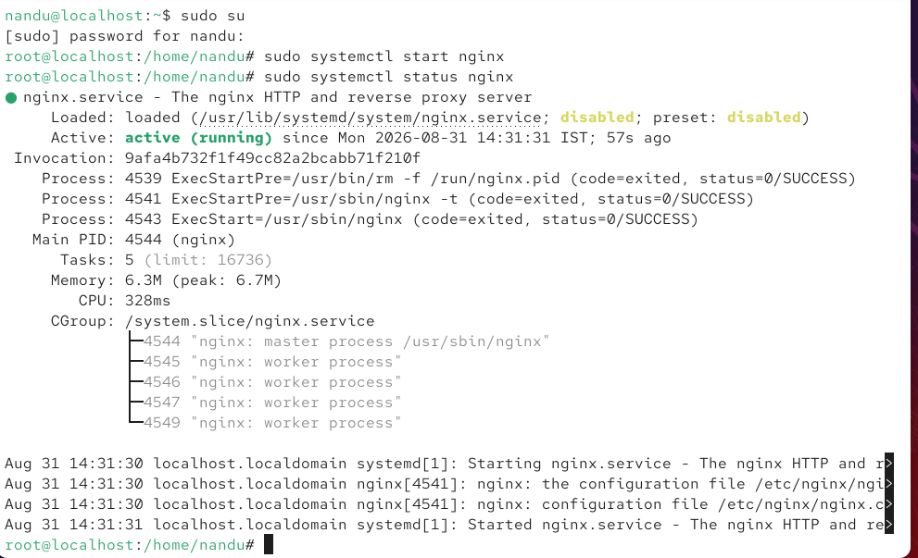

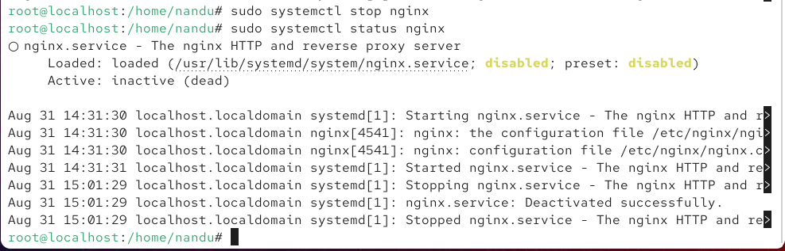

3. Enable the cron service to start automatically on boot, then reboot your system and confirm that the service is running after reboot.

ANS:

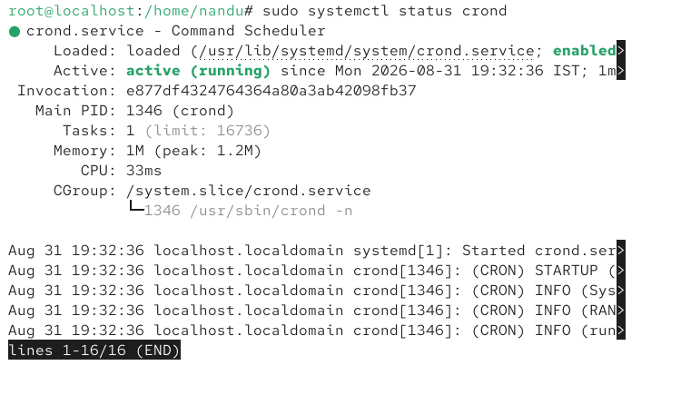

4. List all currently running services using systemctl and identify any service related to networking (like NetworkManager or networking). Write the current status of that service.

ANS:

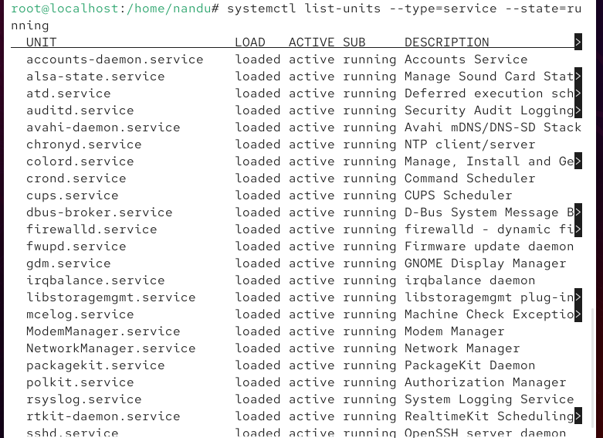

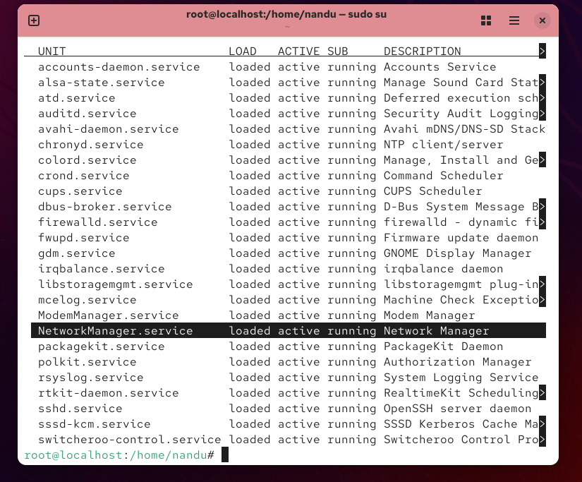

5. Simulate a real-world scenario: Imagine you are troubleshooting why Spotify Web cannot stream music on your Linux machine. Use systemctl to check if the firewall (ufw or firewalld) service is running, and if it is, disable it temporarily. Document each command used and the result. Only disable the firewall if you are on a safe, non-production environment.

ANS:

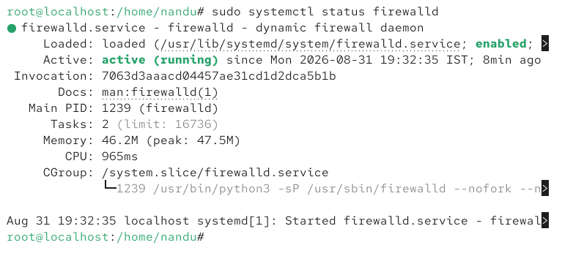

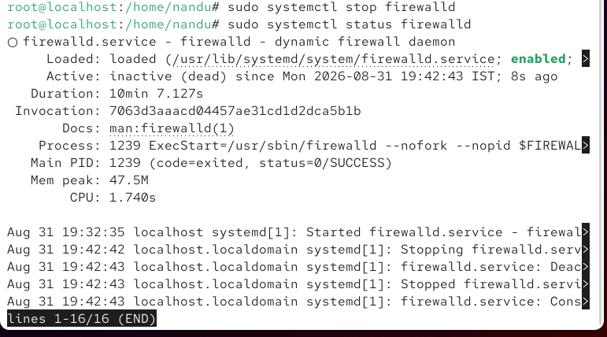

The firewalld service was checked using systemctl and was found to be running. The service was temporarily stopped using sudo systemctl stop firewalld. After stopping it, the status changed from active (running) to inactive (dead). This can be used as a troubleshooting step to determine whether the firewall is interfering with Spotify Web connectivity.

